Manual Testing

- JIRA - Dashboard

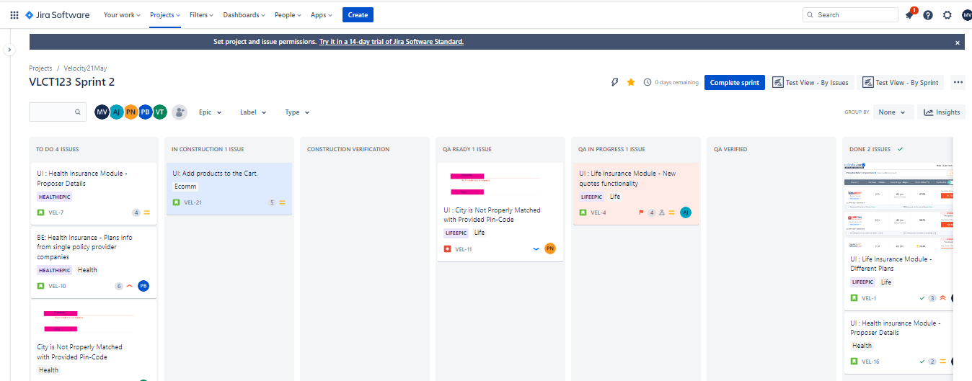

- User Story 01 :-

ECDP 0011 - UI: Add products to the Cart.
Description - User should able to add a product to cart.
Acceptance criteria -
- Product can be added to cart.
- Cart quantity can be changeable.
- Minimum Quantity should be 1 and Maximum Quantity depends upon available products.
- Product can be removed from cart.
- New product can be added to the cart.
- Total and subtotal should be visible.
- Cart total may vary as per the product quantity.
- User can able to save the cart.
- User can able to checkout from cart.

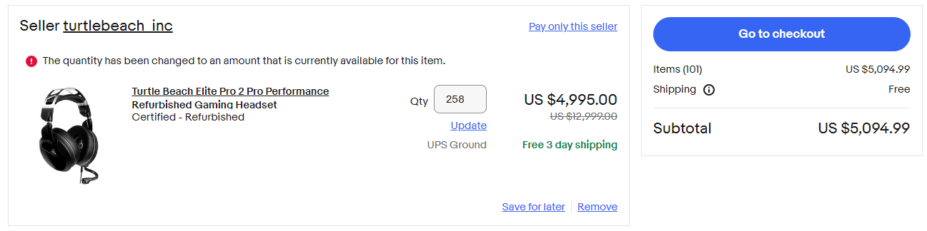

Test Cases :-

- Verify that selected product is properly added into cart or not.

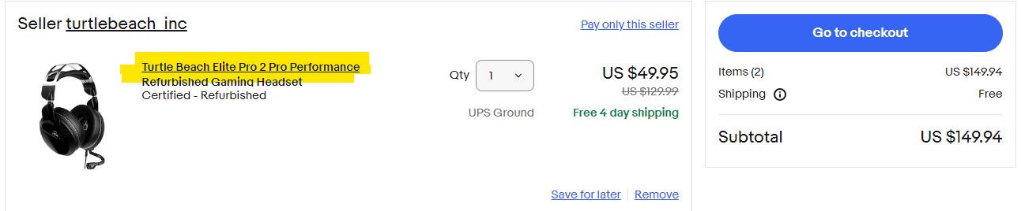

- Verify that user can change the product cart Quantity.

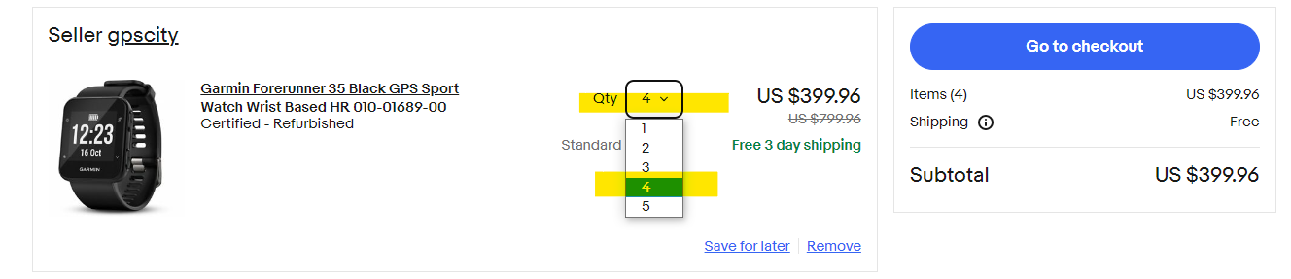

- Verify that Minimum Quantity user can add into cart is 1.

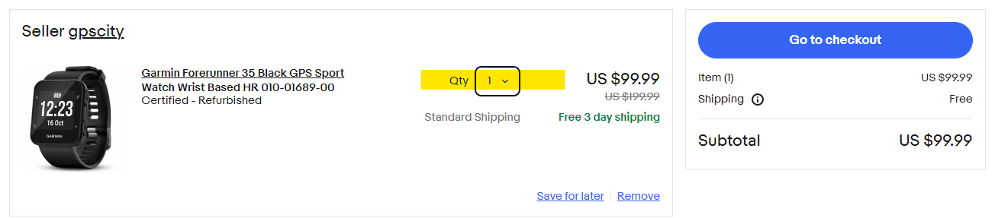

- Verify that Maximum Quantity user can be add into cart is depends on available products.

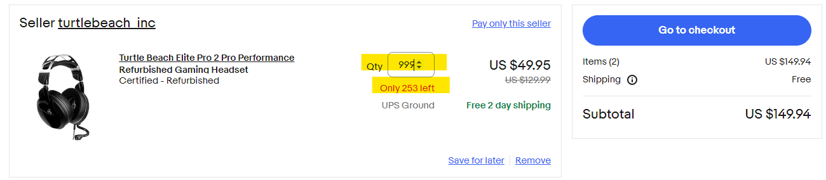

 | Values | Valid/Invalid
Min-1 | 0 | Invalid
Min | 1 | Valid
Min+1 | 2 | Valid
Max-1 | 252 | Valid
Max | (Available Quantity) 253 | Valid
Max+1 | 254 | Invalid

- Verify that Product can be removed from cart.
- Verify that New product can be added to the cart.

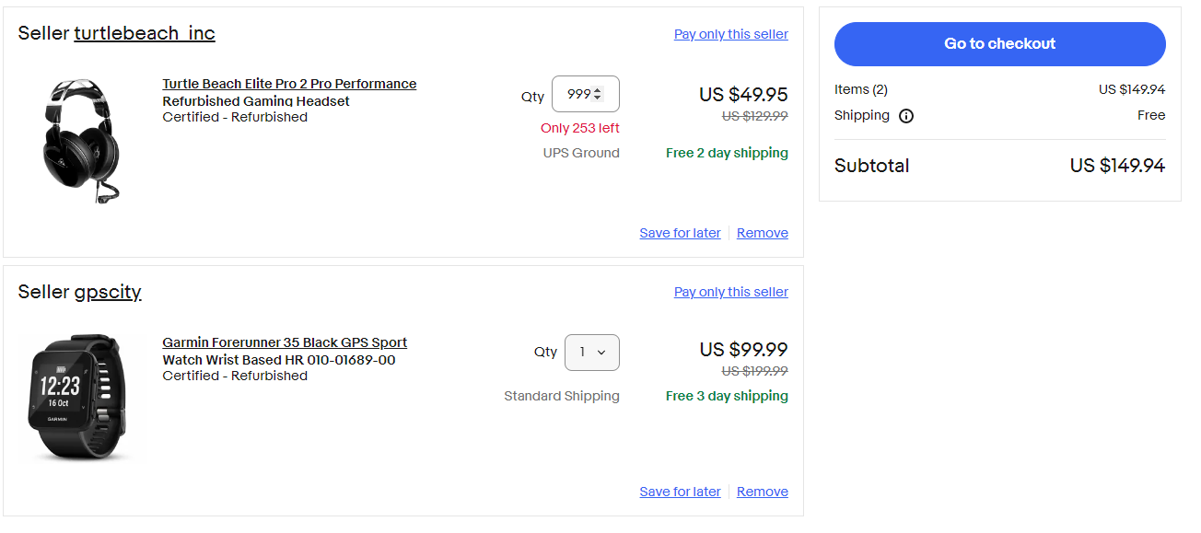

- Verify that Total and subtotal should be visible.

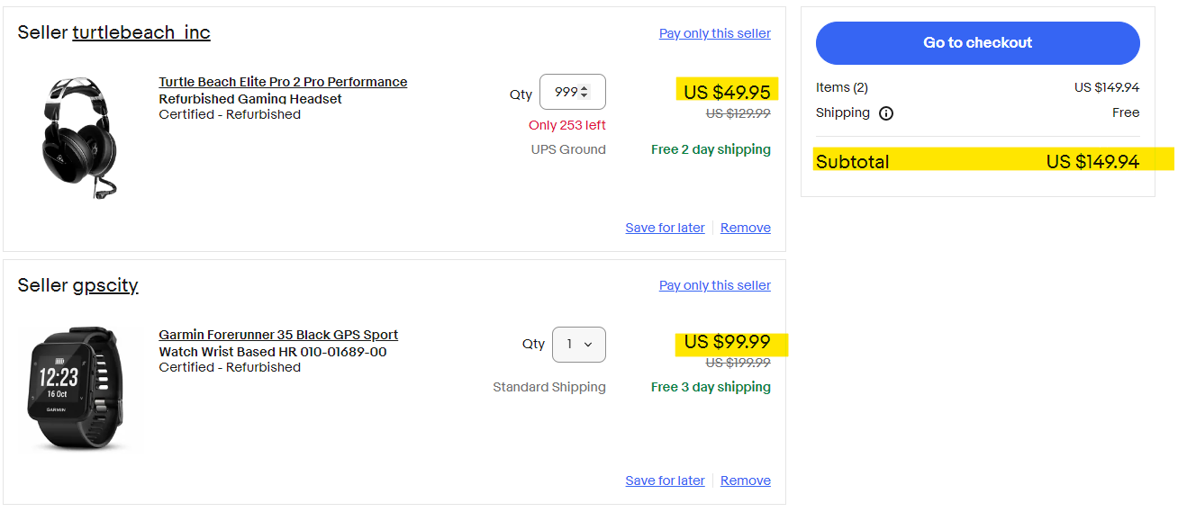

- Verify that Cart total may vary as per the product quantity.

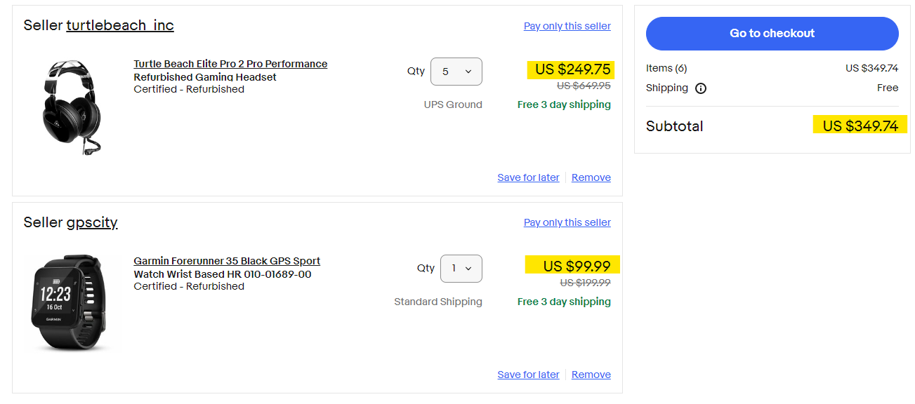

- Verify that User can able to save the cart.
10.Verify that User can able to checkout from cart.

- User Story 02 :-

ECDP 0022 - UI: Product Detail Page
Description - User should able to verify the Product Detail Page.
URL - 3M camcorder projector Shoot And Share Never Used Red Plastic Still On Camera | eBay
Acceptance criteria -
- Buy it now, add to cart, make offer, add to watch list options should be visible on Product Detail Page Options should be visible.
  - Shipping
  - Delivery
  - Varies
  - Returns
  - Seller does not accept returns | See details- for more information about returns
  - Payments
- First image should be by default selected /displayed, sub images should be available, user can able to select / hover to zoom / zoom on the images / left right image view.
- Seller information should be displayed, user should have option to contact to seller.
- Similar and related products should be suggested.
- Product description, shipping and payment options should be displayed.

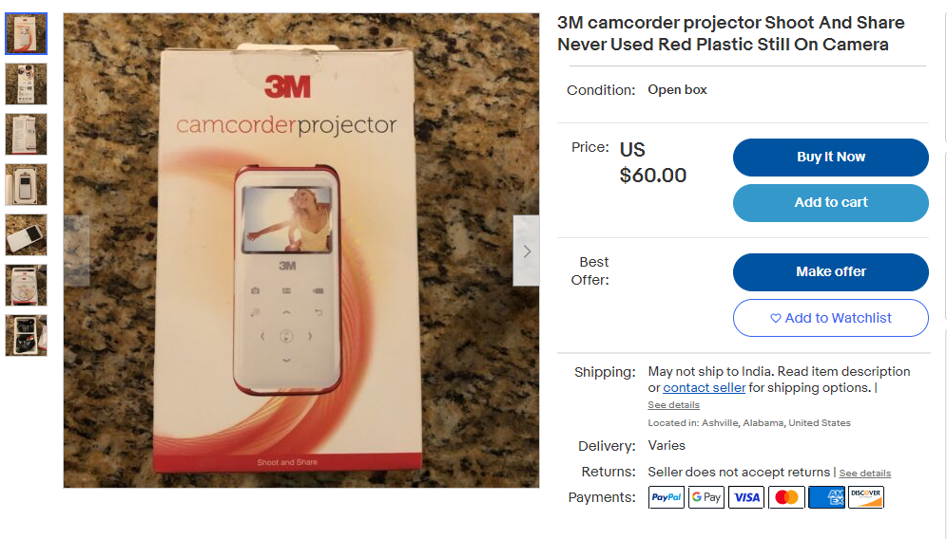

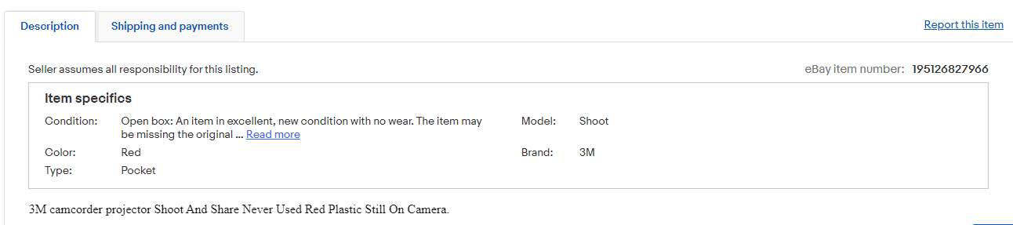

Defect ->

ECDP 1123 : Defect: UI: Quantity Text-box accepting special characters.
Description -
1.On Product details page, The Quantity text-box is accepting Special characters (!,@,#,$,%,^,&,*,(,),?,>,<).
2.These special characters should not accepted by that text-box.
Steps to Reproduce -
- Go to ebay Website.
- Select any one product.
- Go to Product Details Page.
- Then give special characters as input to the Quantity text-box.
Defect Screen-Shot -

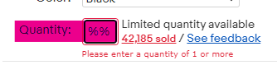

- User Story 03 :-

ECDP 0033 - UI: Product Listing Page
Description - User should able to verify the Product Listing Page
URL - https://www.ebay.com/b/Electronics/bn_7000259124
Acceptance criteria -
- Main category should be visible at URL and left side filter header.
- All filters should be displayed at Left Hand Side.
- Drop down arrow should visible for sub category.
- Drop down arrow should maximize the respective sub category / collapse the subcategories.
- Selected filter should get applied and reflect in URL.
- Shop by Brand / Shop by model options should visible after applying the filter.
- Option for grid/list view should visible.
- User can apply sub filters as per the choice.
- Pop-up should be visible for applying the filters.

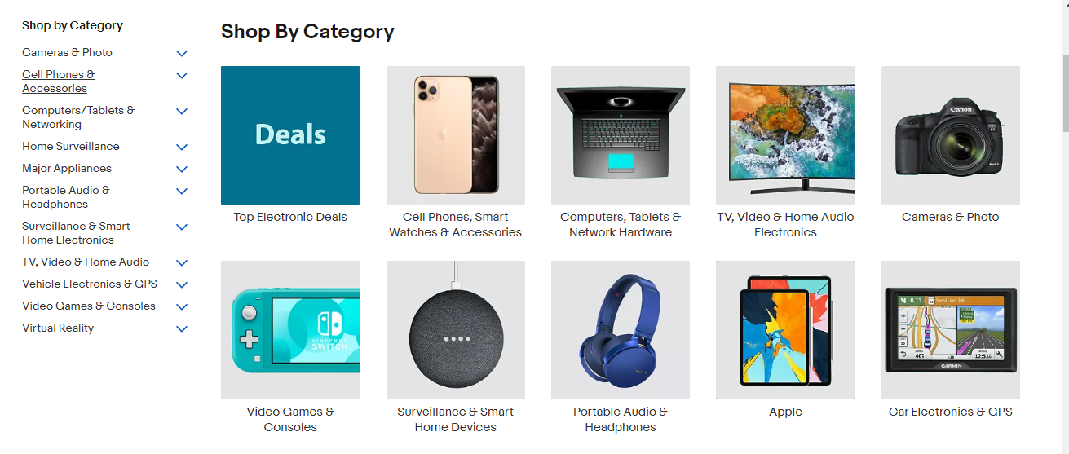

- User Story 04 :-

ECDP 0044 - UI: Sub-Filters
Description - User should able to apply sub filters
URL - https://www.ebay.com/b/Camcorders/11724/bn_42
Acceptance criteria -
- User should able to click on filters.
- Pop-up should get visible for filters.
- User should able to choose multiple filters / single filter.
- Applied filters should visible at bottom of pop-up.
- After selection should get reflect to URL.

